

**MAIL SERVER GUIDE**

--------🙟🟑🙝--------

**Mr:**

1. **Hao Anh Ha – Student680595**
2. **Phong Hong Nguyen – Student683948**
3. **Chien Quoc Phan – Student603739**

**Submitted By:**

**Mr. Hao Anh Ha**

**Authorized Signature:**

**Mr. Le Van Long**

**Date of Issued:**  *26/09/2014*



# Contents:

## *Chapter I: Problem Definition*

1. *Introduction:* 4
2. *Existing Scenario* 4

## *Chapter II: Requirement Specification* 5

1. *Proposed Solution:* 5
2. Design project by DFD/UML 6

## *Chapter III: Architecture and Design Project*

1. *Tiers of Application* 6
2. *Design project by DFD/UML* 7
3. *Design Flow chart* 16

## *Chapter IV: Entity Relationship and Database Design/Structure* 25

**REVIEW 1**

# Chapter I: Problem Definition

## Introduction:

Our client is a Principal of SRS College. It generally runs the courses for B.Tech, B.Pharmacy, M.B.A and M.C.A. For the convenience of the students they had even started part time courses for the above mentioned courses. They generally conduct the entrance examination every year and based on that, the seats are filled in that institution. The notifications for the entrance examination, the results for the entrance examination are generally displayed through the news papers and the college website.

Every year as the college begins, the details of the courses, the list of holidays, the list of examinations for the courses will be designed, and will be displayed on the college notice boards. Any further changes will then be intimated by circulating the notices to the respective class rooms. And after the website is built for the college, the notifications are displayed on the college website.

Now they want an email server, where they can create the email accounts for their students, and communicate directly to the students with the help of this email server. There by intimating the students about the college events, examinations, notifications, etc. through their respective email ids. Also with the help of this mail server, they want to provide home works or assignments for their students through the mails. There by bridging the communication gap between the students. And thus they directly intimate the students regarding the notifications, events, etc.

# Chapter II: Requirement Specification

## Proposed Solution***:***

The site must have the Logo of the institution and must be followed in all other pages. The Home page must be properly distributed in the section to display different notification. The Admin will have the authority to modify the data of the site and also to enlist the details of all the students, staff.

For increasing the communication the customer wants the site should have facility for their staff and students to create the account. In order to authenticate their staffs and students admin will enter the details like ID, Name, and Address of the student. Then the list of their ID and Password would be provided to them. With the help of these details the staff or student will login their account and are supposed to change the password on the first attempt. Once it is changed the system should ask for Log out and then the user will login with their new account. This message must prompts for first time change in password. Once the account is created they can edit their profile data.

**Page Designing: can be displayed**

1. There should be a logo indicating the brand of the institute on all the web pages. (Note: the logo can be of any institution or it can be designed by your own as well).
2. On the Home page the list of the new events, Login section (staff, admin, student), Result, Admission Form downloads, Contact us, Staff details along with the qualification, Advertisement link for job announcements. The upcoming events, Topper details in one section, an image of the College Campus, the link for navigation.
3. Staff Login: Staff will login the website with the authentication details provided to them and change their password once login, can edit their profile. Staff will also allocate the assignment, homework through their account and can forward to the entire student eligible for the course. Staff can see the details of the students in the college in order to select their E-mail Id foe sending the assignment.
4. Student Login: student also will login with the authentication provided by the college before changing the password and must be followed by updating the database. There should be link to check the assignment allocated to them.

**Function to be performed:**

**ADMIN:** Admin will provide the data of the website like what are the upcoming events, entering the list of the holiday, entering the details of the staff, students. Admin can see the data of all the staffs and students.

**STAFF:**

1. Staff once entered must update their profile by adding professional, personal, educational details. Staff will also provide the email-Id so that the student can use to send the query.
2. Each staff can view all the students of the college with their Email-ID, Courses they had opt and must be allowed to filter the data.
3. They can select the required email-Id with the help of the checkbox then select a copy email-ID. The copied Email-ID must be pasted TO section of the mail and then assignment must be attached and send to the students.
4. There should be link named **COMPOSE** where the staff can send the assignment to the students.

**Note :**

1. The Message with the Assignment heading must go the INBOX of the student as well as the Assignment section in the student Home Page.
2. There should be an **INBOX** link also where they can see the query send by the students and must have the option to **REPLY** the mail.

**STUDENT:**

1. Student will also login the same way the staff has done. They will also edit their profile details. Unlike staff they cannot view the staff personal and professional data. They can get the staff Email-ID through the Staff details link of the site.
2. There would be an assignment link to check the assignment they have allocated.
3. They can send query to the staff with the help of the **COMPOSE** option.
4. They can check their **INBOX** to see the response of their query

## Functional Requirements

* **Mainly Input/ ouput:**
* **Ex:**
  + **Input:** 
    - Login ( username, password…)
  + **Output**:
    - Sucess
* ***Benefits:***

**Technical System requirements**

* **Developer:**
  + **Hardware:** Desktop ,Intel®
  + **Software:** Eclipse ,NetBean, SQL Server 2012.
* **User:**
  + **Hardware:** Desktop ,Intel®.
  + **Software:** Internet Explorer, Mozilla Firefox, Google Chrome, Opera

# Chapter III : Architecture and Design Project

## Tiers of Application:

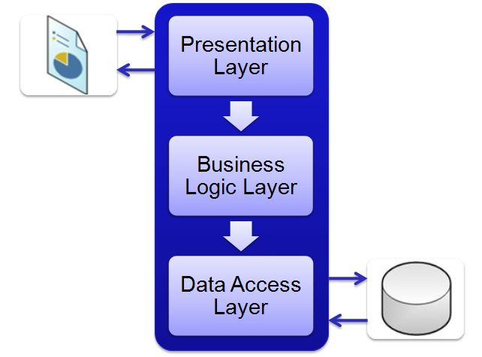

## Design project by DFD/UML:

Definition - What does *Unified Modeling Language (UML)* mean?

Unified Modeling language (UML) is a standardized modeling language enabling developers to specify, visualize, construct and document artifacts of a software system. Thus, UML makes these artifacts scalable, secure and robust in execution. UML is an important aspect involved in object-oriented software development. It uses graphic notation to create visual models of software systems.

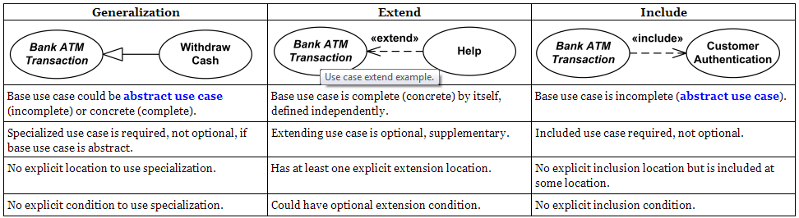

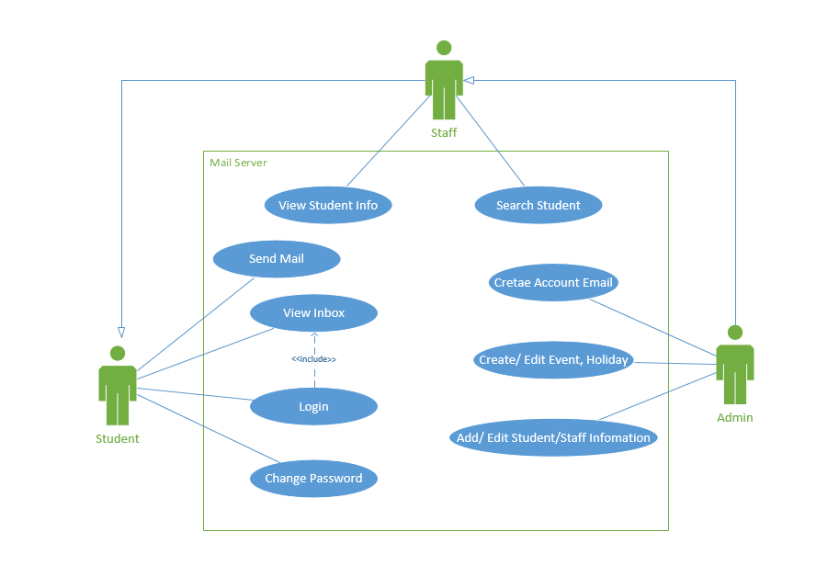

|  |  |  |  |
| --- | --- | --- | --- |
| **Use case name**: Login | **ID**: 1 | | **Important level**: High |
| **Primary actor**: Admin, Staff, Student | | **Use case type**: Detail, necessary | |
| **Stakeholders and interests**: Admin, Staff, Student | | | |
| **Brief description**: Login to use functionality of the mail | | | |
| **Trigger**: Admin, Staff, Student  **Type**: | | | |
| **Relationships**:  Association: Admin, Staff, Student  Include:  Extend:  Generalization: | | | |
| **Normal flow of events**:   1. Login in system | | | |
| **Sub flows**: | | | |
| **Alternate/exceptional flows**: | | | |

|  |  |  |  |
| --- | --- | --- | --- |
| **Use case name**: View Inbox | **ID**: 2 | | **Important level**: High |
| **Primary actor**: Admin, Staff, Student | | **Use case type**: Detail, necessary | |
| **Stakeholders and interests**: Admin, Staff, Student | | | |
| **Brief description**: View mail’s received in Inbox | | | |
| **Trigger**: Admin, Staff, Student  **Type**: | | | |
| **Relationships**:  Association: Admin, Staff, Student  Include:  Extend:  Generalization: | | | |
| **Normal flow of events**:   1. Login in system 2. View mail’s received | | | |
| **Sub flows**: | | | |
| **Alternate/exceptional flows**: | | | |

|  |  |  |  |
| --- | --- | --- | --- |
| **Use case name**: Send Mail | **ID**: 3 | | **Important level**: High |
| **Primary actor**: Admin, Staff, Student | | **Use case type**: Detail, necessary | |
| **Stakeholders and interests**: Admin, Staff, Student | | | |
| **Brief description**: Compose a mail to send | | | |
| **Trigger**: Admin, Staff, Student  **Type**: | | | |
| **Relationships**:  Association: Admin, Staff, Student  Include:  Extend:  Generalization: | | | |
| **Normal flow of events**:   1. Login in system 2. Click button “Compose” to compose a mail 3. Click button “Send” to send mail | | | |
| **Sub flows**: | | | |
| **Alternate/exceptional flows**: | | | |

|  |  |  |  |
| --- | --- | --- | --- |
| **Use case name**: Change Password | **ID**: 4 | | **Important level**: High |
| **Primary actor**: Admin, Staff, Student | | **Use case type**: Detail, necessary | |
| **Stakeholders and interests**: Admin, Staff, Student | | | |
| **Brief description**: | | | |
| **Trigger**: Admin, Staff, Student  **Type**: | | | |
| **Relationships**:  Association: Admin, Staff, Student  Include:  Extend:  Generalization: | | | |
| **Normal flow of events**:   1. Login in system 2. Select “Change Password” 3. Input new password 4. Click buttom “Save” to save | | | |
| **Sub flows**: | | | |
| **Alternate/exceptional flows**: | | | |

|  |  |  |  |
| --- | --- | --- | --- |
| **Use case name**: View All Student | **ID**: 5 | | **Important level**: High |
| **Primary actor**: Admin, Staff | | **Use case type**: Detail, necessary | |
| **Stakeholders and interests**: Admin, Staffs | | | |
| **Brief description**: | | | |
| **Trigger**: Admin, Staff  **Type**: | | | |
| **Relationships**:  Association: Admin, Staff  Include:  Extend:  Generalization: | | | |
| **Normal flow of events**:   1. Login in system 2. View all Student | | | |
| **Sub flows**: | | | |
| **Alternate/exceptional flows**: | | | |

|  |  |  |  |
| --- | --- | --- | --- |
| **Use case name**: Search Student | **ID**: 6 | | **Important level**: High |
| **Primary actor**: Admin, Staff | | **Use case type**: Detail, necessary | |
| **Stakeholders and interests**: Admin, Staff | | | |
| **Brief description**: | | | |
| **Trigger**: Admin, Staff  **Type**: | | | |
| **Relationships**:  Association: Admin, Staff  Include:  Extend:  Generalization: | | | |
| **Normal flow of events**:   1. Login in system 2. Input Id Student 3. Click button “Search” 4. Return results | | | |
| **Sub flows**: | | | |
| **Alternate/exceptional flows**: | | | |

|  |  |  |  |
| --- | --- | --- | --- |
| **Use case name**: Create Student/Staff ’s Account Email | **ID**: 7 | | **Important level**: High |
| **Primary actor**: Admin | | **Use case type**: Detail, necessary | |
| **Stakeholders and interests**: Admin | | | |
| **Brief description**: | | | |
| **Trigger**: Admin  **Type**: | | | |
| **Relationships**:  Association: Admin.  Include:  Extend:  Generalization: | | | |
| **Normal flow of events**:   1. Login in system 2. Create Account 3. Input information of Student/Staff 4. Click button “Create” | | | |
| **Sub flows**: | | | |
| **Alternate/exceptional flows**: | | | |

|  |  |  |  |
| --- | --- | --- | --- |
| **Use case name**: Add/ Edit Student/Staff Infomation | **ID**: 8 | | **Important level**: High |
| **Primary actor**: Admin | | **Use case type**: Detail, necessary | |
| **Stakeholders and interests**: Admin | | | |
| **Brief description**: | | | |
| **Trigger**: Admin  **Type**: | | | |
| **Relationships**:  Association: Admin.  Include:  Extend:  Generalization: | | | |
| **Normal flow of events**:   1. Login in system 2. Click button “Add Student/Staff” or button “Edit Student/Staff” 3. Input information 4. Click button “Save” | | | |
| **Sub flows**: | | | |
| **Alternate/exceptional flows**:  Unable to empty the information marked with * | | | |

|  |  |  |  |
| --- | --- | --- | --- |
| **Use case name**: Create/ Edit Event/Holiday | **ID**: 9 | | **Important level**: High |
| **Primary actor**: Admin | | **Use case type**: Detail, necessary | |
| **Stakeholders and interests**: Admin | | | |
| **Brief description**: | | | |
| **Trigger**: Admin  **Type**: | | | |
| **Relationships**:  Association: Admin  Include:  Extend:  Generalization: | | | |
| **Normal flow of events**:   1. Login in system 2. Click button “Create Event/Holiday” or button “Edit Event/Holiday” 3. Input information 4. Click button “Save” | | | |
| **Sub flows**: | | | |
| **Alternate/exceptional flows**: | | | |

# Chapter IV: Entity Relationship and Database Design/Structure

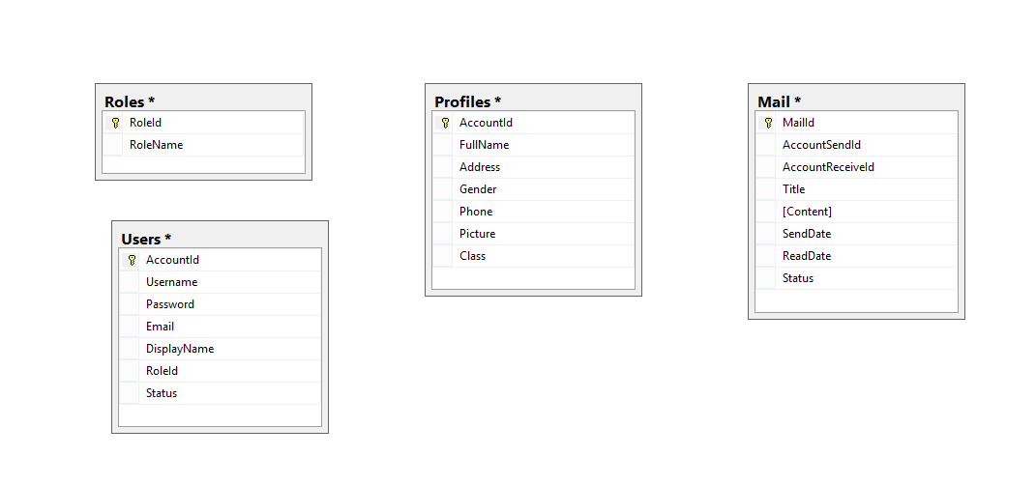

# Chapter V: Task Sheet

|  |  |  |  |  |  |  |
| --- | --- | --- | --- | --- | --- | --- |
| Project Ref No: | | Project Title | Activit Plan repared by: | Date of Reparation of Activities | | |
| Sr.No | Task | Actual Days | Team  Member Name | Status |
| 1 | Project Definition | Mail Server Guide |  | 1 | Nguyen Hong Phong  Ha Anh Hao  Phan Quoc Chien | Completed |
| 2 | Architecture and Design project |  | 2 | Nguyen Hong Phong  Ha Anh Hao  Phan Quoc Chien | Completed |
| 3 | Data Flow Diagram |  | 1 | Nguyen Hong Phong  Ha Anh Hao  Phan Quoc Chien | On going |
| 4 | Database design/structure |  | 2 | Nguyen Hong Phong  Ha Anh Hao  Phan Quoc Chien | On going |
| 5 | Design Layout Website |  | 2 | Nguyen Hong Phong  Ha Anh Hao  Phan Quoc Chien | On going |
| 6 | Document and User Guide |  | 2 | Nguyen Hong Phong  Ha Anh Hao  Phan Quoc Chien | On going |

**REVIEW 2**